**Part 1:**

Code

while True:

try:

# Ask user for charge for food

food_charge = float(input("Enter the charge for the food in US Dollars: "))

# Check if the number is positive

if food_charge > 0:

break # Exit the loop if the input is valid

else:

print("The number is not positive. Please try again.")

except ValueError:

# Handle the case where the input was not a number

print("Invalid input; please enter a numeric value.")

# Calculate tip

tip = food_charge * 0.18

# Calculate sales tax

sales_tax = food_charge * 0.07

# Calculate the total amount

total_amount = food_charge + tip + sales_tax

# Display the results, rounding to the nearest cent

print(f"The charge for the food is ${food_charge:.2f}")

print(f"The tip of ${tip:.2f} is then added.")

print(f"The tax amount of ${sales_tax:.2f} is then added")

print(f"This makes the total amount ${total_amount:.2f}")

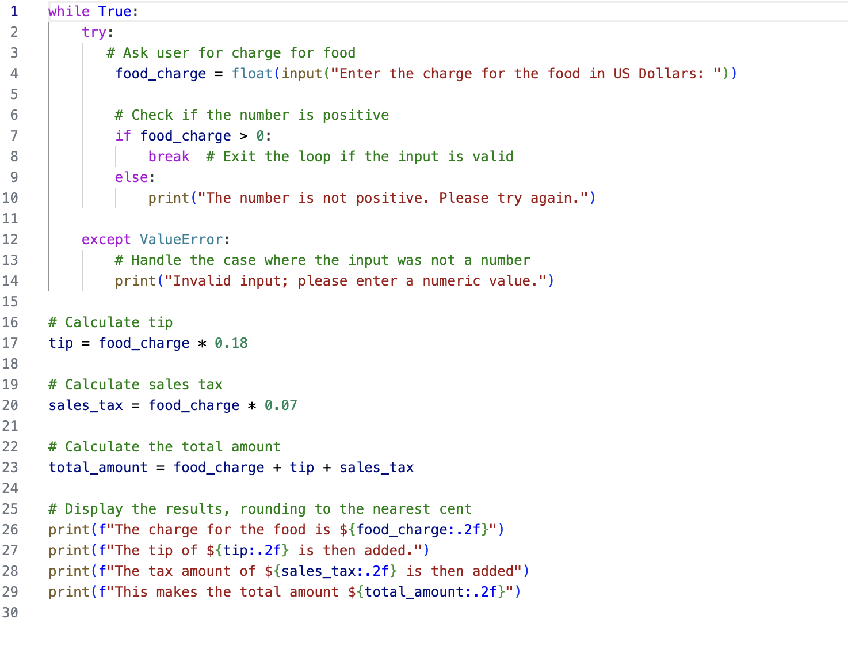

**Part 2**

Code

def calculate_alarm_time():

while True:

try:

# Ask user for the current time in the traditional format

current_time = input("Enter the current time (HH:MM): ")

# Split the input into hours and minutes

hours, minutes = map(int, current_time.split(':'))

# Ensure the time is valid

if not (0 <= hours < 24) or not (0 <= minutes < 60):

print("Invalid time. Please enter a valid time.")

continue # Use continue to ask for input again

# Get the number of hours until the alarm

hours_until_alarm = int(input("Enter the number of hours to wait for the alarm: "))

# Check if the number is positive

if hours_until_alarm > 0:

break # Exit the loop if the input is valid

else:

print("The number must be positive. Please try again.")

except ValueError:

# Handle the case where the input was not a number

print("Invalid input; please enter a numeric value.")

# Calculate the new hours and minutes

total_hours = hours + hours_until_alarm

alarm_hours = total_hours % 24

# Display the result, preserving the original minutes

print(f"The alarm will go off at {alarm_hours:02}:{minutes:02} on the 24-hour clock.")

# Run the function

calculate_alarm_time()

